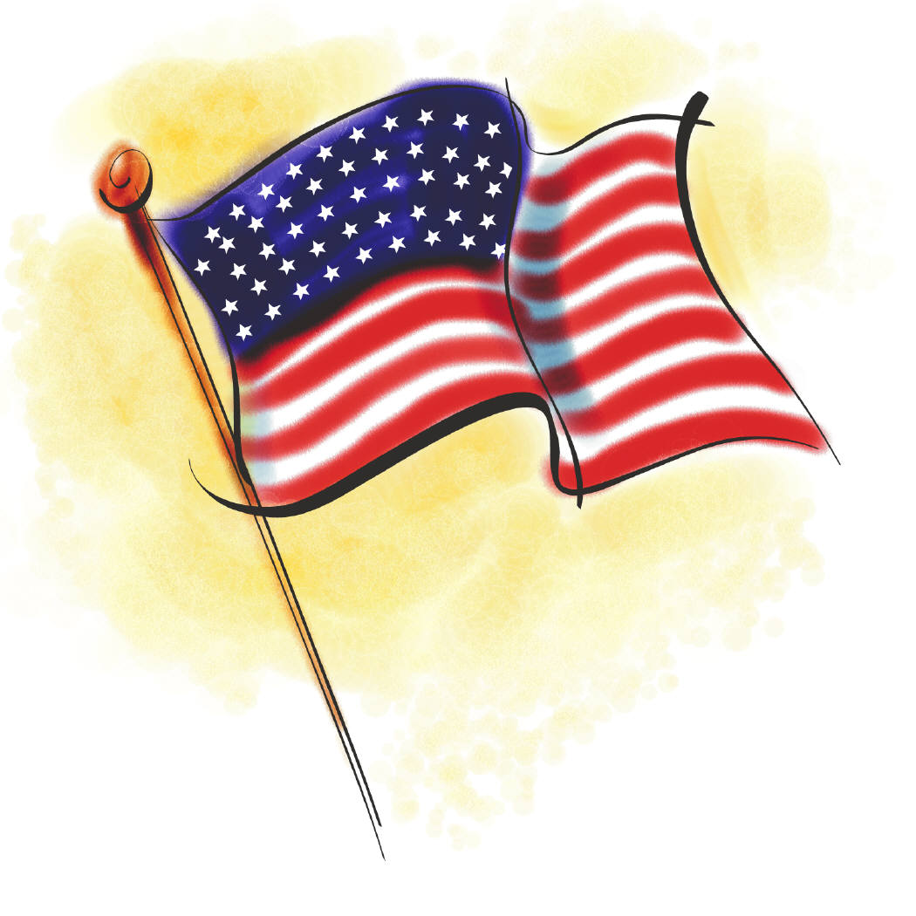

Saturday, January 21, 2017
at the Historic Courthouse

Featuring

- Keynote Presentation and Panel Discussion featuring the Chief Legal Officer and General Counsel of BlackBerry Ltd. on Individual Privacy vs. Collective Security: The Encryption Wars and Corporate America.

- Judges’ Panel led by Presiding Judge James Herman addressing bias in the legal profession from the Judicial perspective.

- Courses include Ethics, Elimination of Bias, Substance Abuse, Developments in Family Law, Land Use Law, Corporate Law and Trusts and Estates Law.

6.5 Hours of MCLE Credit
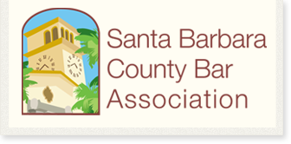

Bench & Bar Conference

 | Registration Payments received | On or before 1-6-2017 | After 1-6-2017
 | SBCBA Members | $110.00 | $130.00
Registration Form | Non-SBCBA Members  New Admittee/Public Interest Attorneys  Three or More Attendees from Same Firm or Organization | $130.00  $90.00  $90.00 | $150.00  $90.00  $90.00

Name | Email | Firm | Membership status
 |  |  | Mbr Non-mbr
 |  |  | Mbr Non-mbr
 |  |  | Mbr Non-mbr
 |  |  | Mbr Non-mbr
Payment: ___ SBCBA members at $110 $130 _______.00
___ non-SBCBA members at $130 $150 _______.00
___ new admittee/public interest at $90 _______.00
___ 3+ from same firm/org. at $90 _______.00 Total: $_________
To register and pay by credit card, call SBCBA at 569-5511. Otherwise, mail completed registration form with payment to SBCBA, 15 West Carrillo, Ste. 106, Santa Barbara, CA 93101. Attach additional sheets for additional registrants.

